**URGENT REQUEST FORM**

**Requestor’s Manual**

1. **Go to** [**http://10.27.1.170:9292/default.aspx**](http://10.27.1.170:9292/default.aspx) **and login your account.**

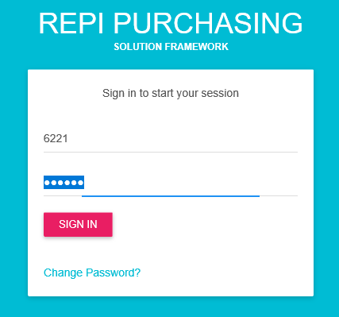

1. **Navigate URGENT REQUEST FORM then click the positive sign (+) button to see all options assigned to your account.**

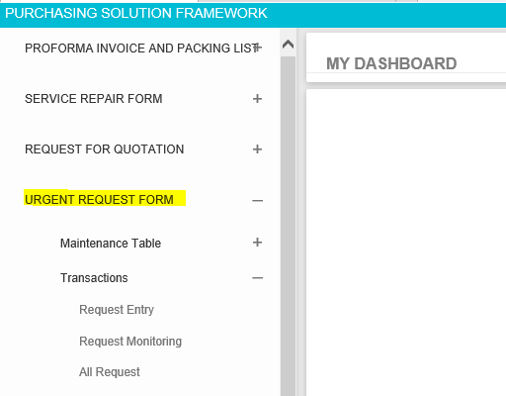

1. **If you want to create new request then go to URGENT REQUEST FORM > Transactions > Request Entry**

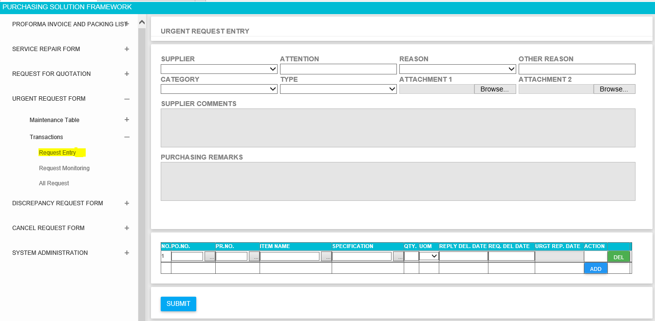

* **3.1 Enter all required field before submitting the request. If you missed to fill up required fields then the system will inform you by marking red colors. See example below;**

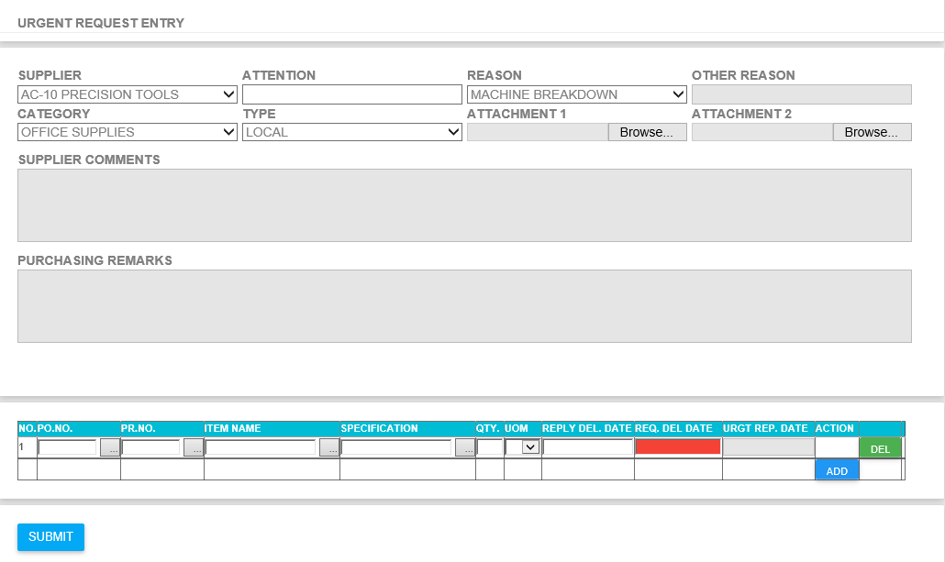

* **3.2 If you have an attachment, please make sure that you finish first all the details before attaching file if there is any. Its like how do it in RFQ Module.**

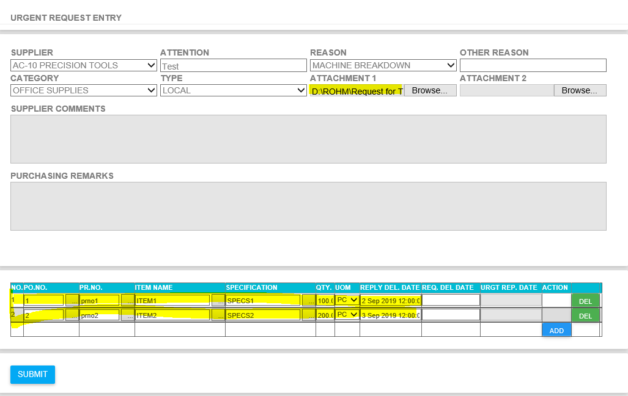

* **3.3 You will be redirected to success page if there is no error after clicking SUBMIT Button**

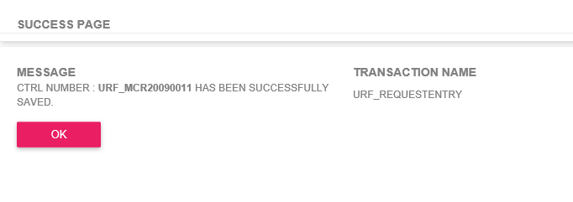

1. **If you want to check or monitor your request the go to URGENT REQUEST FORM > Transactions > Request Monitoring**

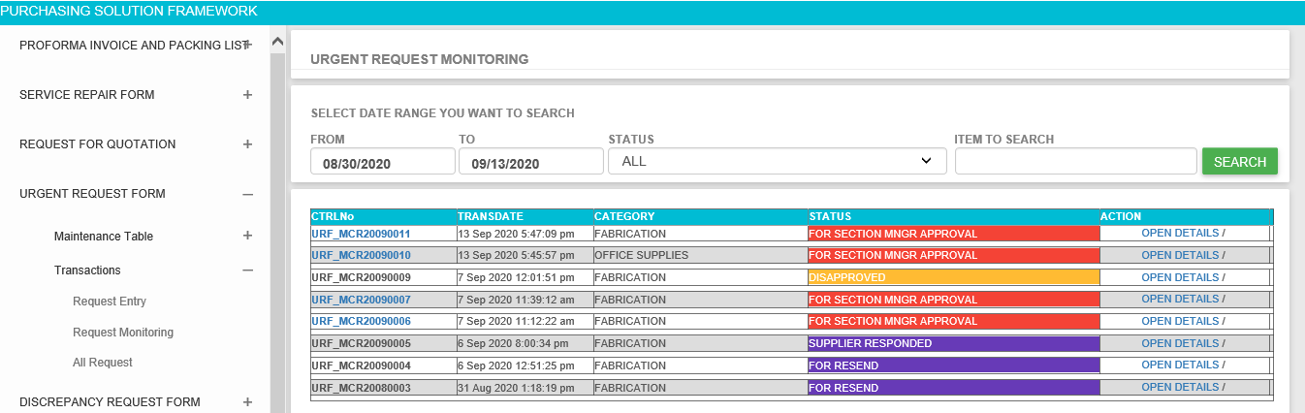

* **4.1 Click OPEN DETAILS if you want to see the request details**

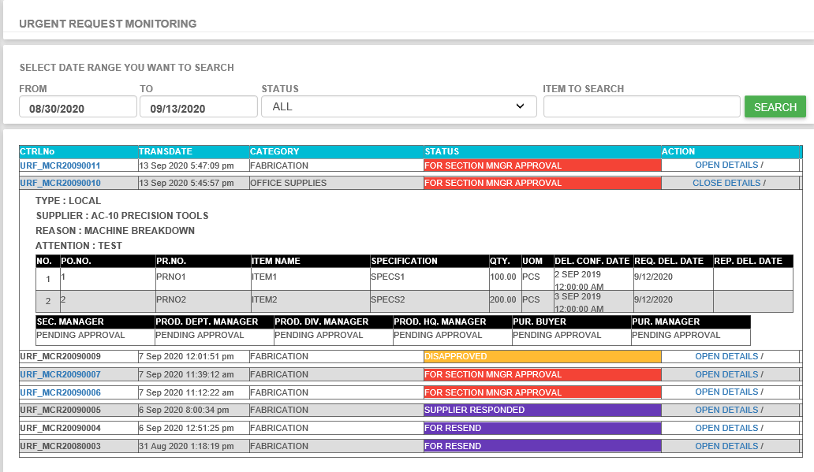

* **4.2 If you missed something on your request then you have chance to update it before your section manager approve the request. Click the URF Number on the left side then you will be redirected to the request entry to update your request.**

1. **If you want see all request the go to URGENT REQUEST FORM > Transactions > All Request. This page is almost the same with the RFQ All Request Form for your referrence.**

